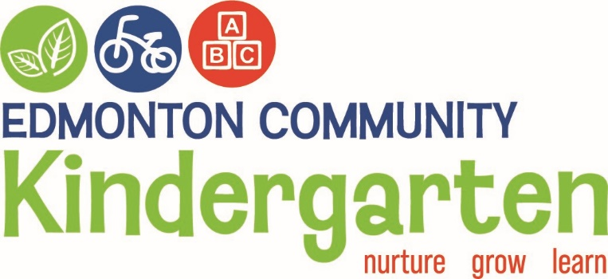

247 Edmonton Road, Te Atatu South, Auckland. Phone 836 3566, Email-info@edmontonkindy.co

PHILOSOPHY

We at Edmonton Community Kindergarten believe children learn best in a safe and stimulating environment under the guidelines of Te Whāriki.
At Edmonton Kindergarten we will develop an awareness of our Bi-cultural heritage and respect the principles of Te Tiriti o Waitangi.

Each child is viewed as an individual, irrespective of gender, culture or special needs, and will be given equitable opportunities to learn and develop at his/her own pace and level.

Staff acknowledges and value both planned and emergent learning experiences and takes every opportunity to broaden the child’s knowledge through these experiences. We acknowledge the role of parents/whanau as first teachers. Positive steps are taken to respect and acknowledge the aspirations held by parents and whᾱnau for their child.

To ensure that all children develop a lifelong love of learning and to provide a firm foundation for their journey through life, they will be given the encouragement and opportunities to:
- Become independent and individual thinkers.
- Work within acceptable limits and boundaries.
- Develop problem- solving skills and social competence as well as the concept of Manaakitanga.
- Develop the development of pro-social skills.
- Develop effective communications skills.
- Make and sustain friendships/Tuakana Teina.
- Feel confident about who they are and what they can do.
- Develop their own Wairua (spirit) and support others Wairua (spirit).
- Develop confidence to make their own choices.
- Learn about their place in the community.
- Develop an awareness of kaitiakitanga and future sustainability of our environment.
- Developing an awareness of keeping ourselves healthy.
Licensing Criteria For Early Childhood Education and Care Centres 2008 and Early Childhood Education Curriculum Framework – Governance, management and administration GMA5 Fundamental beliefs, values, and attitudes.
NELP Objective 1. (1)“Ensure places of learning are safe, inclusive and fee from racism, discrimination and free from racism, discrimination and bullying. (2)” Have high aspirations for every learner/ākonga, and support these by partnering with their whānau and communities to design and deliver education that responds to their needs, and sustains their identities, languages and cultures”.
13-02-2024

